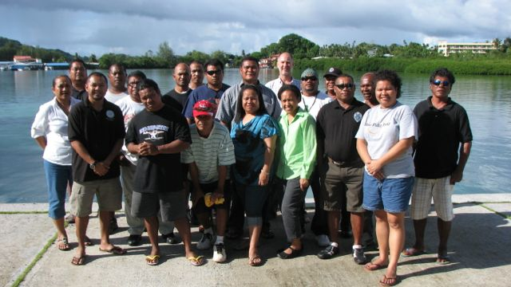
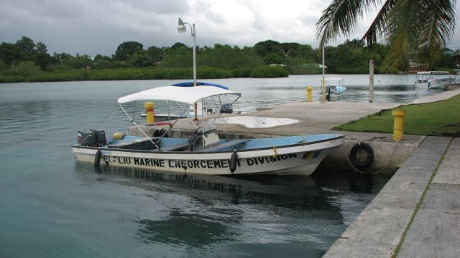

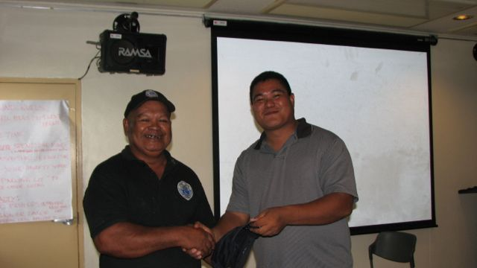
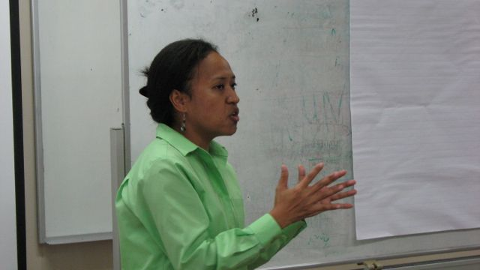

PROCEEDINGS
Palau Conservation Enforcement Workshop
on Standard Operating Procedures

Wednesday, November 30 – Saturday, December 3, 2011

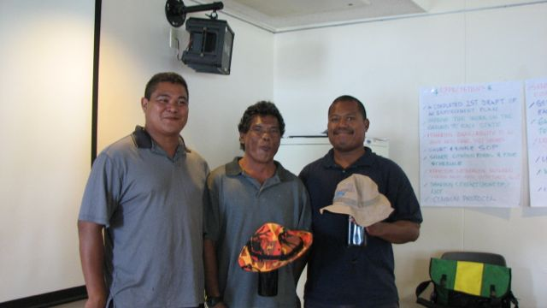
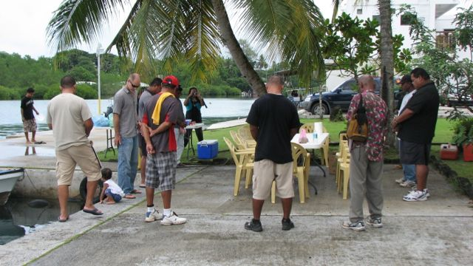

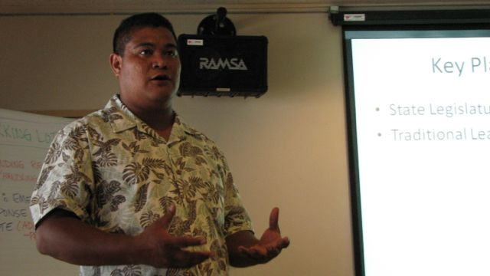
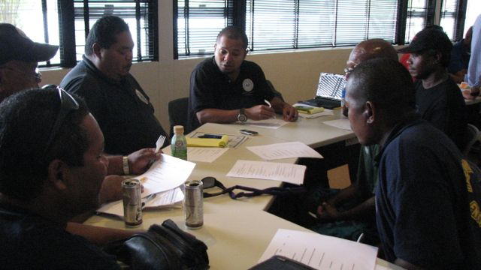

CONTENTS

Letter to the Governor ………………………………………………………. 1
Workshop Objectives and Agenda ………………………………………………………. 2-4
Ground Rules and Expectations ………………………………………………………. 5
Participant List ………………………………………………………. 6
SOP Topics and Scenarios ………………………………………………………. 7-18
Discussion Notes ………………………………………………………. 20-23
List of Disseminated Materials ………………………………………………………. 24
Press Release ………………………………………………………. 25

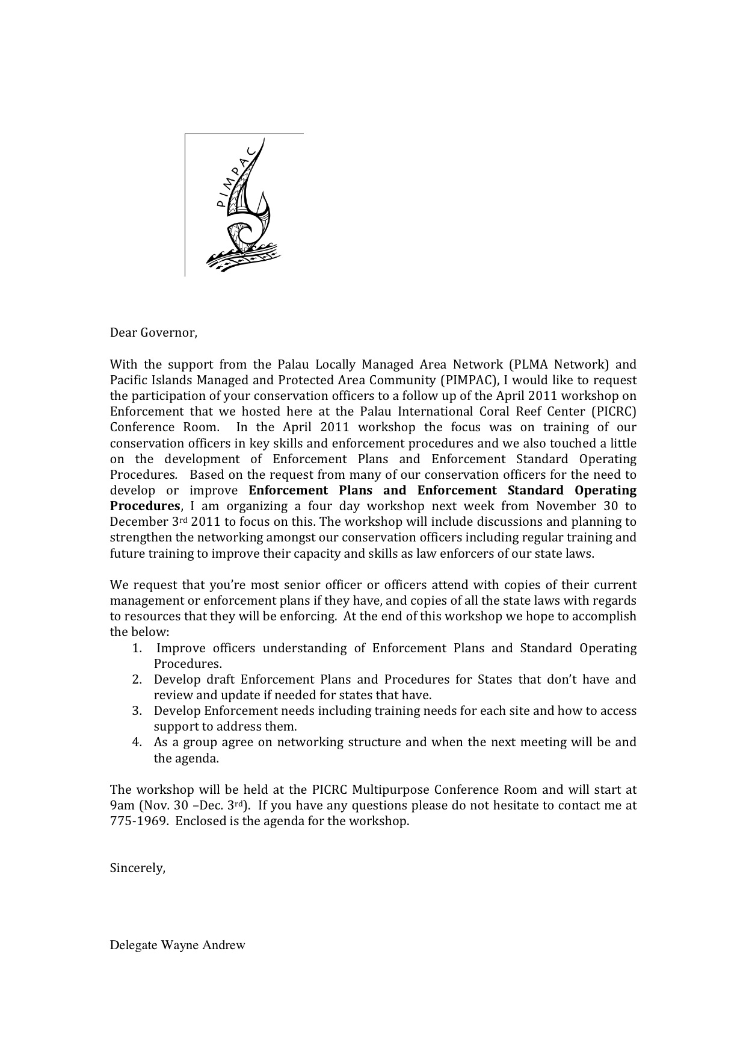
WORKSHOP INVITATION LETTER

Palau Enforcement Training Workshop

Dates: Wednesday, November 30 – Saturday, December 3, 2011
Venue: Palau International Coral Reef Center Multipurpose Conference Room

Workshop Objectives:

The workshop objectives are to:

- Improve Officers Understanding of Enforcement Plans and Standard Operating Procedures
- Develop draft Enforcement Plans and Standard Operating Procedures for States that don’t have and review and update if needed for states that have.
- Development Enforcement needs including needs for each site and how to access support to address them.
- As a group, agree on a networking structure and time and agenda of the next meeting for follow on activities.
- Allow officers to share their experiences to help improve their work as conservation officers.

Day/Time | Topic
DAY 1 – Wednesday, Nov. 30

9.00-9.30 | - Workshop opening and welcome  - Introduction to workshop purpose  - Introductions of participants  - Notices and housekeeping
9.30-9.45 | - Background on Enforcement Plan and Standard Operating Procedures
9.45-10.00 | - Review of April 2011 Workshop and draft Enforcement Plans for sites that participated
10.00-10.15 | Morning Tea
10.15-12.00 | - Review of the different sections of model Enforcement Plan Outline
12.00-1.00 | Lunch
1.00-3.00 | - Break into small groups and work on completing site enforcement plans
3.00-3.15 | Afternoon tea
3.15-5.00 | - Break into groups and works on completing each sites enforcement plan (cont.)
5.00 | Adjourn
DAY 2 – Thursday, Dec. 1
9.00-9.15 | - Recap on DAY 1, introduce DAY 2  - Notices
9.15-10.15 | - Break into groups and works on completing each sites enforcement plan (cont.)
10.15-10.30 | Morning tea
10.30-12.00 | - Report back to the plenary on each site progress on their Enforcement plan
12.00-1.00 | Lunch
1.00-2.00 | - Presentation on the sections of Enforcement Standard Operating Procedures
2.00-3.00 | - Breakout into groups and develop site Operating Procedures
3.00-3.15 | Afternoon Tea
3.15-5.00 | - Breakout into groups and develop site Operating Procedures (cont.)
5.00 | - Adjourn
Day 3 – Friday, Dec. 2
9.00-9.15 | - Recap on DAY 2,  - Introduce DAY 3  - Notices
9.15-10.00 | Breakout into groups and develop site Operating Procedures (cont.)
10.00-10.15 | Morning tea
10.15-12.00 | Breakout into groups and develop site Operating Procedures (cont.)
12.00-1.00 | Lunch
1.00-3.00 | Breakout into groups and develop site Operating Procedures (cont.)
3.00-3.15 | Afternoon tea
3.15-5.00 | - Report back to plenary  - Groups present key elements of SOP drafts, and important suggestions, lessons learned and/or next steps.
5.00 | Adjourn
Day 4 - Saturday Dec. 3
9.00-9.15 | - Recap on DAY 3,  - Introduce DAY 4  - Notices
9.15-10.00 | - Brainstorm on Training needs for each site and for the network as a group  - Introduction of Site Training Manuel Topics/Outline
10.00-10.15 | Morning tea
10.15-12.00 | - Presentation on LMMA History  - Presentation on Belau LMA History  - Discussion on Future Network structure  - Set date and place of the next meeting and draft agenda  - Workshop Evaluation
12.00-1.00 | - BBQ Lunch  - Informal Sharing and Social  - Adjourn

PALAU SOP WORKSHOP GROUND RULES AND GUIDELINES

GROUND RULES:
- Put cell phones on silent/vibrate mode
- Be on time
- Speak your mind and language you are most comfortable to express yourself in
- Be respectful of each other
- Raise your hand to share something
- Have a “parking lot” to capture other notes
Penalty for breaking a ground rule:
- 10 push ups
- Sing or dance
- Formal oral apology to group
- Provide betelnut for the group

WORKSHOP EXPECTATIONS:
- A completed 1st draft of enforcement plan
- Improve the work on the ground at each State
- Sharing ideas and ability to go back and share with leaders
- Short and simple SOP
- Share citation forms and fee/fine schedules
- Effective networking between States and also with National government
- Share contact lists or point of contacts
- Common protocol
- Share copies of documents with everyone
- Get together and learn from each other and know what’s happening at different sites
- Gain knowledge about topics
- Learn how to effectively communicate
- Update SOP
- What to do next… networking
- Idea of frequency of violations in protected areas

PALAU SOP WORKSHOP PARTICIPANTS LIST

Name  Rosania Victor  Ismael Renguul  Elwais Samil  Milton Sioich  Quincy Oiterong  Rngechl Dlutaoch  Estephan Kintaro  Harry Blesam  King Malsol Sam  Verano Ngirkelau  Ngirachewes Aderkeroi  Alson Ngiraiwet  Hadley Renguul  Erwin Moses  Albino Fernando  Mike Henry | State/Department/Agency  Helen Reef project  Ngiwal State  Peleliu Enforcement division  Peleliu Enforcement division  Ngatpang State  Koror State Rangers  Koror State Rangers  Koror State Rangers  Koror State Rangers  Ngchesar State  Ngardmau State  Ngardmau State  Ngarcholong State Conservation Officer  Helen Reef project  Helen Reef project  Angaur State | Title  Program Manager  Conservation Officer II  Enforcement  Officer Ranger  Officer Helper  Captain  Captain  Captain  Rock Islands  Development Officer  Conservation Officer  Conservation  Conservation Officer  Conservation Ranger  Conservation Helper  Deputy Program Manager/Fiscal Officer  Conservation Officer

SOP TOPICS AND SCENARIOS

SOP Topics:
- Organization structure/Chain of Command
- Integrity: Conduct & appearance
- Safety
- Violations
- Maintenance
- Orientation/Training
- Appendix:
  - Timeline/scheduling (work schedule)
  - Checklists

Levels of Action:
- Observation/recording
- Issue of citation
- Arrest & confiscation

Scenarios:

VIOLATIONS

SCENARIO - You spot a boat in the MPA with line in the water (fishermen in the water) you advise them to leave and they are hostile towards you. What is the proper procedure to follow from when you spot them to when you leave?

  - Report sighting to base office. [base this is speedboat #2. We’ve spotted boat in mpa. Standby for info.] Harry – also good to inform National police in case their back up is needed. Shared story about approaching a hostile party and officers were not armed only speargun (towath). The party said if anyone touched his boat he would spear them. He knew the party and talked with him to calm down “come on man, it’s not worth it” The person calmed down a citation was issued.]
  - Do short briefing amongst officers on board. Assigning roles, etc.
  - Do a proper approach. [safe stopping distance from other boat. Based on experience safe distance would be 10-20ft. at stern. Keep violators in sight at all times. Do not lose visual sight of violators. Use speakerphone, can speak from a safe distance. EQUIPMENT – handheld camera with GPS positioning. ]
  - Identify yourself as an officer to the violating party. Even though your boat maybe clearly marked as a patrol boat, you will still need to identify yourself as a conservation officer. [note: name plates for officers. ]
  - Inform them that they are within the MPA.
  - Gather all relevant info needed [Id violator boat, boat operator, fishermen, # of persons (violators), fishing activities]
  - Issue citation and collect evidence. [take pictures, gather all other info]
  - Witness violators leave before you leave. Do not leave while the violators are still in the MPA.
  - Report back to base.
  - Debrief with officers.
Notes: Wayne, should there be other communications between base during the event or just at beginning and at the end. King – example, if a boat of 10 PI fishermen is found and they are asked if they have fishing permit and if working relationship is good with National, the officers can call to get verification on fishing permit.

- Topic on dealing with hostile situations. Training on how to deal with it. King – short video. Using common sense.
- King: it does not mean that everytime you spot someone in the MPA, you issue citation. If you spot someone and inform them that they are in the MPA and he was not aware and is cooperative with them and you judge that he is being honest to just give them a warning. But you log it down. This way you don’t create an enemy but they will be more cooperative in the future.
- Koror state: a list of all registered boats with their numbers are available onboard with patrols.
- Mike L. – how many have someone at base at all time that can support them?

SCENARIO - You’re off duty at a community customary event and someone brings in State regulated species (exp: clam) and a National regulated species (exp: Napoleon wrasse). What do you do?

  - As a duly sworn officer, you are required to uphold the laws at all time. Act normal in the customary event.
  - Contact State authorities and National Fish and Wildlife. (Incident report)
      - On duty officer receiving calls: initiate an incident report, identify an officer who is not related to the customary event to respond to the scene
  - Follow up on the case. At another time with the head of the event.
  - Cite, as appropriate

SCENARIO - You’re doing your regular patrol and you come across a vehicle parked next to a bird sanctuary with a gun in his possession feathering a Blogol. What do you do?

  - Report sighting to base [location, violation description]
  - Base will inform Fish and Wildlife
  - Conservation officers brief before approaching party
  - Approach and identify yourself as a conservation officer
  - Inform party that they are next to a protected area
  - Gather info and evidence. Get info on vehicle, party name, take the rifle (if the circumstance safely allows for it). Keep the person with you
  - Once officer report on scene to relieve you, brief officer.
  - Report back to base via VHF or cell
  - Initiate an incident report

SAFETY

SCENARIO - You’re designated as the training officer and your department just hired 3 new officers, what are the safety and training needs for these officers?

  - Check officers training level (background)
  - Introduce new officer to the dept.
  - Orient new staff with the rules & regulations of employment, SOP, compliance plans (key note: develop an orientation package that includes all that all officers need to be aware of, develop checklist of minimum trainings)
  - Put officer on duty as observers day/night shift (3 months)
  - Undergo training in Police Academy, if not done
  - After 3 months, evaluate the three new officers, SOP test
Notes: most cases of hire need training/not trained; helicopter hire; training list for all officers, identify top 3 training needs

SCENARIO - If you’re getting ready to go on routine patrol, what are the things you do to prepare?

  - Assumption is marine patrol:
    - Check boat condition (hull, oil/engine, prop, battery)
    - Check fuel, ropes, and anchor line
    - Ensure all onboard surveillance equipment are functioning (safety kit, citation forms, binocular, GPS, radio, food, drinks, raincoat, flash light, betelnut
    - Brief captain. Log time of departure (date and time) and expected ETA
Note: can develop checklist

SCENARIO - You’re on foot patrol within the bird sanctuary and you come across a car accident and there are people injured and one is dead, what training and equipment do you need to deal with the incident?

  - Assess and secure scene for your safety/victim, note time of incident and determine type of injuries
  - Call 911 then contact base office either via VHF or cell phone. If utilizing VHF, communication protocol needs to be followed
  - Proceed to apply CPR and first aid
  - Base office will contact 1st responders (BPS/ambulance) [Note: Base follows emergency SOP, should trigger filling of incident report form]
  - Stay on the scene and continue applying first aid and CPR until ambulance arrives
  - Conservation officer write incident report and submit to shift captain or supervisor. Include name of officers who relieve him on site.

Note: need communication device and CPR or life support training
Integrity:

SCENARIO - You’re the supervisor and you come to work and your conservation officers are not there. An hour later they are still are not there. 3 hours later, they show up drunk, what do you do?

  - Try to contact the officers to know why have not shown up to work
  - Follow policy and procedures manual [employment manual]
    - See appropriate procedures to apply [incident report to include actions from the policies and procedures manual]
      - Verbal warning
      - Written warning
      - Suspension
      - termination
  - Contact shift leader/supervisor on different shift to cover the shift for them [shift rotation is considered. Can pull members from pm shift or swing but not from grave yard to am]
  - Send officers home when they show up drunk
  - Supervisor, rearrange shift, dock pay, document in employees’ evaluation
  - Submit incident report to supervisor (director)
Note: Wayne – in his experience supervising others, he maintains a log book of encounters with his staff whether it’s negative or positive. This helps with evaluating and also holding the staff accountable.
King – public safety officers need to be held at a higher standard than other employees of the state

SCENARIO - You’re at the port and your supervisor and governor just came back from a fishing trip and they have undersized groupers, what do you do?

  - Log time/date/location
  - Identify yourself [governor, I’m sorry but I’m just doing my job… it’s also off season so I’ll have to inform Fish & Wildlife]
  - Full identification of the boat
  - Check for evidence [size, species, number]
  - Citation
  - Write an incident report

SCENARIO - You’re off duty partying at the bars and someone threatens you and you know decide to leave. The person follows you outside and you know your baton is in the trunk of your car. What do you do?

  - Stay calm/calm yourself
  - Try to solve the problem and avoid physical contact; keep a safe distance
  - Try and seek assistance from the bar’s bouncer.
  - Call 911 and describe the incident and the persons involved in the incident.
  - Make sure the person stays within your sight
  - Stay until on duty officers come and you show them the person
Note: DO NOT EVEN THINK OF THE BATON IN YOUR CAR OR TIRE WRENCH OR STONES, ETC.
Equipment: current equipment issued now don’t have fire arms or batons.

SCENARIO - You’re the senior officer and you’ve had staff showing up at work intoxicated and you’ve reported the incident. You’re governor asks you to wrote up a policy on incidents and use of alcohol, what is your recommendation?

  - 1st offense - Verbal warning
  - 2nd offense - Written warning
  - 3rd offense - Suspend with no pay for 1 week
  - 4th offense - Termination or force to resign
Note: Koror State chain of authority in disciplinary action: 1st offense sit down and talk with the officer and try and settle problem (seek assistance for the individual) and shift supervisor log in note pad, create an incident report and file in his employee file; Supervisor →Director →Human Resource
Maintenance:

SCENARIO - Your state regularly maintains equipment. You know that the patrol boat engine has not been properly serviced for two years and you’ve brought this up with your supervisor and no actions have been taken. What do you do?

  - Pull out all the daily maintenance record for the past two years
  - Pull out record for the dates/time of past report of the problem to your supervisor
  - Draft a letter addressing the problem
  - Sign and send one to your supervisor and a copy to the director and if necessary to the maintenance personnel
Note: Assumption, you maintain a maintenance log. You keep a communication log or you keep a file of all correspondence.

SCENARIO - Your conservation officer just returned from routine patrol and the propeller on the boat is broken and the handheld GPS unit is missing. You asked them what happened and they tell you that he took the short cut and it was low tide but he does not know what happened to the GPS but he says it was on the boat when they left. What do you do?

- Ask officers if they are okay, not hurt, etc.
- Check for any additional damages besides propeller and GPS
- Ask them to secure the boat (anchor or pull it up on dry dock)
- Ask officers exactly what route they took and why they took that route. Be professional, ask in good manner.
- Check the check-list/log book if GPS was present when they left
- Write incident report
- Review compliance/employee plan relating to incident. Next day, take appropriate action according to compliance plan and since it’s first time give verbal warning. Inform them they are responsible for damage costs & replacement of GPS, if compliance/employee handbook states so. If GPS was present on checklist before departure, ask them to keep an eye on the lost GPS on the routes they took.

SCENARIO - Your generator blows up because there was no more oil. What do you do?

  - Find a light (flashlight, etc – do not use lighter) switch communication system to VHF portable. Plug in manual phones so can continue to receive calls. If database is needed, have a computer on UPS to have access to database.
  - Secure area for oil spill or gas spill. Gather everything you need. Open ventilation to generator room
  - Wait until daylight
  - Find a mechanic
  - Log the incident into the log book
  - Write an incident report
  - Investigate who is responsible with maintenance
  - Take proper action/document action [refer to employee manual]

CHAIN OF COMMAND

SCENARIO - As of today, what (draw) is your organizational structure?

  - Koror State
    - Director
    - Shift Captain
    - Senior Officer
    - Officer I, II, III
  - Angaur State
    - Governor
    - Conservation Officer
  - Ngaralong State
    - Same as Angaur
  - Tobi State
    - Governor
    - Senior officer
    - Conservation officer
  - Peliliu State
    - Administrative Officer
    - Chief Ranger
    - Senior officer
    - Officer

SCENARIO - You’re a Hatohobei State conservation officer and you observed a violation within the Koror State MPA. What do you do?

  - Identify boat number (ID boat and get full description, # of person)
  - Identify the location
  - Call Koror State Rangers soonest possible
  - Koror Rangers respond to site and cite violators
  - After consulting with Governor, agree to testify as witness to incident

SCENARIO - You’re in your conservation office and you receive a call and someone tells you to come to the MPA because there is someone fishing within the MPA. What do you do?

  - Koror State:
    - Get reporter’s name*
    - Log in to log book
    - Relay message to on-duty officers
    - Officers respond to location to assess situation
  - Tobi State
    - Get reporter’s name
    - Log in to log book
    - Call Governor and report incident
    - Governor call marine law division for response
  - Peliliu State
    - Get reporter’s name
    - Site is close to office, one officer will stay in office and one deploys to conservation area
    - Take the name of violator
    - Confiscate the evidence/equipment
    - If they have national violation then call National Fish & Wildlife for response
*Key notes:
- a checklist or form to use when taking calls with specific minimum info to be collected from the caller; ie: name of caller, name of violator, time and date, description and number of individuals, type of boat, location of violation, signature of who took the call to certify info
- incident report – prepared after officers respond, should connect to checklist or form intake from call

SCENARIO - You see a boat in the MPA with fishing gears and coolers in the boat but you don’t see any fish onboard. What do you do?

- Log time/date/location
- Pre-approach Briefing
- Contact base
- Identify yourself to the party as a conservation officer
- Get info on boat, # of people, fishing gears, coolers, etc…
- Approach violator and inform of violation
- Issue citation
- Tell them to leave the MPA
- Prepare incident report
Note: most participants would just give a warning if it’s a 1st time encounter with the party and log down the encounter in notepad.
Wayne – there should be a standard for safety, so base should always be notified before approaching the boat. Had an incident in Tobi where base was informed

SCENARIO - You’re a conservation officer in Ngarachelong State and you receive a phone call from a citizen of your State who is stranded on Hatohobei because he ran out of gas and needs to be rescued. What do you do?

- Collect information from caller… such as date, time, ID the caller, situation and condition of person, etc. and log in log book
- Verify with caller there known contact… inform family members
- Contact Hatohobei State and Marine Law for assistance
- Write incident report
- Submit incident report to Governor
Notes:
William – after step one, prepare incident report and engage Governor. Then Governor will initiate the other steps.
Ismael – officer can take care of immediate actions and then inform Governor.
Wayne – this is great being the last scenario because if we can agree on protocol then maybe Hadley could contact Rosania who is incharge of that area program and ask for their assistance. This should not be for emergency cases only but could be used for violations
Koror state – if it’s negligent such as ran out of fuel, they ask the person to reimburse their fuel. Peleliu also ask parties to reimburse their fuels but they do not.
Berna – operations costs money. How do you deal with it when a different jurisdiction is engaged in rescue or assistance operations?

SCENARIO - You issue a citation and give it to a violator and she rips it up and throws it in the water. What do you do?

- Log in time and date/location on notepad
- Report to base what’s going on
- Issue another citation (if appropriate). If state has littering law, can cite her for littering. Can also visit them later to give citation and talk about issue.
- Describe in notepad
- Prepare incident report
Note: Koror – gears can be taken but not fish. (for evidence) King – fish may be taken if it’s deemed important for the case such as napoleon wrasse. But these are for evidence collection only and returned.
- If you stop a boat and the operator has expired permit and has 30 guests, you charge 30 guests x $??? violation fee. This may exceed the $500 national limit on fines but it’s still inline since you are going by number of counts of violation.
- Have sessions with their AG (legal counsel) to go over laws to understand. So it’s good to go over it quarterly or every 6 months to refresh on laws they are enforcing.
- Koror state citation has four copies – governor, finance, ranger (director gets a copy), violator. 7 working days for violator to contest or settle. After 7 days, the citation becomes a case and goes to court.

SCENARIO – A ship grounding has been reported within your state waters. You are called to assist. You are the first to arrive on the scene. The ship is 100ft long and leaking oil in the water… what do you do?

[assumption is that base has called the patrol to respond to scene, so incident has already been logged into log book]

- Briefing with the team before approaching the boat, how to approach
- Log date/time/tide/location [if no GPS, use fishing line with lead and throw in water to mark location]
- Assess the scene and make sure people onboard are safe [take pictures if possible both surface and underwater photos]
- Call proper authority/call direct to EQPB or you can call Base (if you cannot contact other entities directly) or Marine Law. EQPB is equipped to handle oil spill.
  - On weekend:
- Ask assistance from oil companies (IP&E and Blue Bay) for absorbent pad
    - EQPB – boom and absorbent pad
- Stay at scene and wait for proper authority to arrive. Brief them when they arrive.
- Assist as appropriate
- Make sure you are present when removing vessel. Log down in notepad all times they attempt removal and method of attempt, take pictures, report to base.
- After removal of boat, contact PICRC/CRRF for damage assessment
- Based on damage assessment report, prepare citation with legal counsel
- Complete incident report
Note: Photos should be taken at all stages from beginning of encounter to damage assessment for evidence.

Standard topics (chapters) in an SOP: presented and commented on by participants
- Definitions
- Violations
- Ethics
  - Integrity
  - Appropriate behavior
  - Appearance
  - Disciplinary action
- Chain of Command/Organization chart
- Maintenance of equipment
- Safety
- Training/certification program

WORKSHOP DISCUSSION NOTES

12/01/2011
- Harry – presentation by Lolita that all officers including conservation officers the information collected is crucial for processing of citations and cases in court.

- Quincy – last night boats where in their area collecting sea cucumber (most of them are not from the area) and there was no one there to stop them or advise them not to collect from area, Ngatpang, and hearing all about the current existing laws from yesterday’s workshop I realized that we are not doing anything at our State. We are not doing any enforcement.

- Ship grounding (Peliliu) – importance of collaborating and knowing where to go

- Ngiwal – it’s obvious that even though we all from different areas and may have different situations, we all have the same common goals. Maybe use Koror State as model for other States to follow and make things uniform across the country.

- Erwin (Tobi) – some States don’t have plans so it’s difficult to enforce

- Rosiana (Tobi) – learned about the existing PAN sites – only 8 now

- Albino (Tobi) – all need to have enforcement plans and SOP

- Wayne – there is a wealth of information in the room with each participant; questions that you have, someone else could have gone through the situation and you can learn from them… it’s important that networking is supported

- Hadley – a refresher from the April workshop that Lolita mentioned that information gathering is important. We need to do more so the importance registers in our mind that what we do is important and can contribute to other works.

- Mike – keeping a notepad is important. Recording everything. “If its not written in black and white, it did not happen”

- Ngesaur – when discussing SOP in our small group, I related it to our ground rules that was established at the beginning of our workshop to set some basic rules; so i

- King (Koror) – need to establish effective partnership with National so States can work together with them in achieving. States facing incidents regularly and we cannot address issues because we are not authorized. It takes too long and impedes carrying out duties.

- Koror – didn’t know there were that many PAN sites. Our State currently does not have one yet.
12/02/2011
- Learning from each other. More experienced members present and sharing knowledge, especially Koror State.

- Getting together is best way to learn and sharing. It’s very helpful.

- Important lessons learned – we get occupied with the routine and forget the details or little steps that are very important.

- Dealing with the different scenarios. That was very helpful.

- Koror (Harry) – koror state level is much higher, so we sharing. Lone ranger from Ngesaur and I’m from there so I will also personally help him out.

- Ngesaur – the scenarios, I got it and don’t need to spend all day going through step 1, 2, etc.

- Rosania – learned that each states have different chain of commands.

- Koror (Esteban) – wants to see if we can dialoge with governors to have uniform or standard laws and SOPs for all conservation officers. Uniforms and appearance is very important, professional.

- Peliliu – likes small group discussions and sharing in plenary also very good and would like to get together more frequently.

- Koror (King) – even though Koror state has more years of experience but even the lone rangers have much that we can learn from. Supporting uniform standards. Have a MOU with Peliliu. Example: escorted a mental patient to hospital, so officer told the patient that they were there to bring him to the bank and he went along with them without any struggles. There are things that you will not learn from the books and the previous example is such.

- Wayne – this group networking expands your eyes and ears on the ground.

- Ngiwal – since there is a governors association, there should be a conservation officer network.

- Mike G. – the plans are taking a little bit more time. We had initially looked at site based; however, from feedbacks the plans should be state wide and not just focused on sites since most officers have other duties outside the conservation areas.
12/03/2011
- Harry – liked Wayne’s example of logging supervisory encounters with staff. Will start keeping a log. Very important. What they do, at the end of the shift, make sure you thank the boys for the job they’re doing. Send them off in a good positive mood. Plus and Minus.

- Mike (Anguar) – was very good to know all the different professional skills everyone had.

- Estephan – the most senior on the force, often times we just do things Palauan style and often do not take notes of minor

- Milton – skills in the group is impressive and helpful. Would like to share the training/skills list with all participants so they can contact each other

- Ismael (Ngiwal) – safety first. Not just for yourself but for team and the violator. Be prepared. Have backup of backup. Facts facts facts. Sometimes you got to use your common sense but you have to know your rules and laws.

- Hadley – I realized that if I’m not careful I could get in trouble. I need to follow the rules and laws. Can’t just do what the governor or supervisors tell me to do.

- Erwin – learned from hadley’s report, make sure you have cell phone or VHF

- Albino – as a deputy program manager, makes me more familiar with what our officers need and what they are doing

- Rosania – I work in the office so am not familiar with field, but learned a lot from Koror State’s presentation

- Quincy – I’m not an officer now. He is interested in the discussions and what has been happening. Wants to continue in such efforts to help his State.

- Elwais – refresher info and also help to identify the gaps and help each other to fill those gaps in their States

- Verano - Broad knowledge in this group, surprised with all the skills and trainings that many of the members have gone through. Haven’t been in police academy and I’m out there doing this kind of work.

- William – we’ve taken away the boundaries between us and openly sharing, helping each other, hope it continues

- Ngirachewes – workshop has been very helpful and looks forward to applying things he’s learned, especially in dealing with relatives or close members. Thankful for the workshop

- Mike G. – people are willing to share. If people are put into the right context information will flow

- Wayne – we have instructors amongst ourselves. If the list had not been done, we wouldn’t have known all the skills present. Even if we don’t bring outsiders for training, we can train ourselves. Also learned the needs of the group and can use his leverage as a member of OEK can help get these needs to attention of leadership.

List of Disseminated Materials

- Compliance and Enforcement Program Planning Guide
- Guide to Developing Effective Standard Operating Procedures
- Procedures for Filing Citations
- Site Specific Training Guide
- State-Site Enforcement Orientation Guide
- Topics that Conservation Officers/ Staff Should Be Familiar With
- Telephone Reporting Form

Palau SOP Workshop Press Release
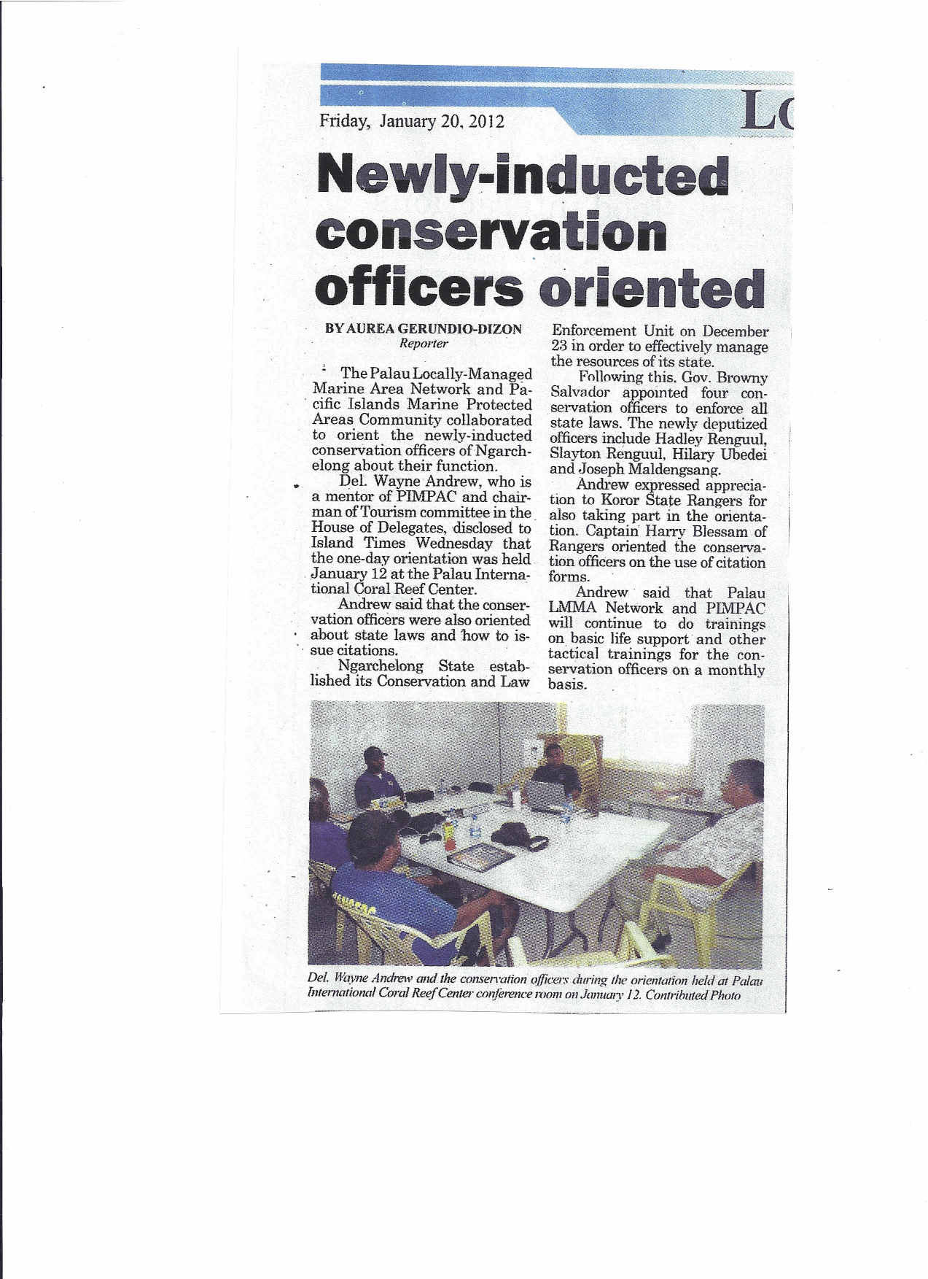

AUDIO NOTES FROM PALAU 2011 CONSERVATION OFFICER SOP WORKSHOP

1) 20111201142453: calling and making a report to the ranger
record on whatever you have- napkin/ scratch paper; call ranger ASAP (as soon as you get to phone communication- not the next day); phone number needs to be available to everyone; you are a credible officer, and it’s important that the call be made immediately

2) 20111201164724: enforcement at difficult situations
Guam guys recommendation: if you see something illegal, walk away and make a report; it will look bad if you proceed with the gather (ex take something from the cooler).
Question: as an off-duty office, you can also submit an incident report?
Answer: It gets added to the incident report; you can be put on as a witness
Question: Now you are in the office and you get a call from your off—duty officer…
People are eating clams illegally, what do you do?
3) 20111201164934: enforcement at difficult situations
(cont. from 20111201164724) Answer: ask someone not related to that family to find me the person in charge of the party and talk to him about the clams. He is the one in charge of that infractions.
It’s a tricky issues approaching customary events.
(Non-English discussion)
At customary events, let it pass, but take enough information and evidence to cite it well.

4) 20111201165720: Debrief, conclusion
Koror State guys are the ones to schedule a date to work on Enforcement Plan with workshop hosts.

20111203104608: Communications with base. (safety. communications)
nobody cam back to tell us/ nobody was at the radio to tell us what was going on; had to stay in the office and wait for someone to call us; the next morning someone called us to say they were told to leave but they had to stay and fix their boat; so we stayed and slept in the office all night, waiting for the call; nobody informed us; because of NOOA standard operating procedure the three of them left for the boat; if they were injured or hostile to them, we would have never known. This is why base, and back-up communication is so crucial- their lives are on the line. This is a great scenario.

20111203105344: Managing Staff: Disciplinary Action (coming to work drunk)
Moderator: My concern is that you are doing a verbal warning; how do you record this? Is there a written warning?
Response: Just sit down and talk to him.
Moderator: We have to differentiate between a written report (or note pad) or written warning. A written warning is from the supervisor that says in the letter: “the last time you did this, I talked to you about it at this time and this place. I’m giving you your second warning, and reminding you that your third time you will be suspended, without pay, and could be terminated if it continues after that.” That’s a written letter going to the violator. It would be nice to keep a record of what they do. As the supervisor, log that. Time of day/date and what you did to address it. Ex: If you did talk to him, log that. “He came late, drunk, I did talk to him, this is what I told him.” If the violator does correct his ways, then you can note it, if he doesn’t, when his evaluation comes up, then you can note that based on that incident.

Question: Should you make a copy of the incident report in the individual’s file?
Answer: Yes, that’s good.

Comment: Now this guy is very skilled, you don’t want to lose him, but his behavior has some problems. So before you terminate him, you try suspension, and or try sending him to a support center similar to AA.

20111203105729: Staff management: Alcohol problems; Communication Lines between supervisor and staff; Training and Employee Agreement
(cont. from 20111203105344)
Sit down and talk to him and see if you can settle the problem.
Once they get their paycheck they just want to blow everything. (laughter)
Re: scenario of staff with alcohol problems

Comment: Seek assistance if they need it. Maybe therapy or support group. As a supervisor I always explain that their work, job, and family is very important to them. When you have a family problem/ crisis they won’t perform well at their job. So if they have a problem, you open that line of communication with them. If you have a problem at work/home, make sure you communicate well. If they don’t come to work because of a family problem, and you are giving them warnings and all this, and you don’t know about it… so you want to make sure you have good relation with your staff: give them room and support when they need it. You invest a lot of time training them, building their capacity and then you lose them… it’s heart breaking. Sometimes… sometimes… officers have to go. Somethings can’t change for them and they have to go. As a supervisor you have to weigh that, and learn from your experience.

Comment: Many people talk about what happens after a candidate gets training and then takes another job. You invest time and money to improve capacity of staff, and then they leave. One way to address that is to sign an agreement that in exchange for building capacity as an employee, they agree to work with your organization for 1-2 years. At least there is an understanding that way.

20111203110528: Marking location
after that we have date and time, tide… (Non-English/laughter)… location. And then you have GPS, or something on board or a small lead weight for fishing. Just tie it to a waterbottle or something and throw it in the water to mark that location- old school style- After that make sure all people onboard vessel are safe.

20111203113012: Scenario: Loss of Equipment (who’s responsible?)
You write the incident report, tell them to go home, the next day they come into work, you call them into the office, tell them it’s their first time, and you are giving them a warning. Tell them to divide the cost of the GPS among them and slowly deduct it from their pay. They agree to that- tell them to keep an eye out for it- if they find it, they don’t have to pay for it.
Question: Make sure your crew is safe first. And you want to show that to your staff. First: “are you guys ok?” // Also, if you check the log and then the assumption is the GPS was there, it’s not there, so they lost it. But if they didn’t check it out, isn’t that another disciplinary action: not going out with full gear?
Answer: Yes, you need a checklist to ensure people go out with full gear.
Comment: Had a incident that a staff came in with a broken prop; working night shift, so he told the personnel to come tomorrow and log everything that you will need to put in your mind- everything you will do; make sure it’s a safe passage.
Question: How many people have an equipment sign-out sheet?
Answer(s): GPS and binoculars are too routine to sign out everyday.
Follow-up: Some equipment may be too routine, but perhaps there is other equipment that should be signed out.
Answer: Every supervisor should make sure the equipment is there/ intact before the other shift leaves.
Question: Who has experience this/ knows of an event when someone has paid for damaged equipment?
Answer: Yah, not only a prop, but also a big spill. (Parking break experience) That person is responsible. He probably just paid half of it, and then we said ok, that’s all right. Maybe over six months.
Comment: A related story to equipment- When I was managing Helen Reef I took a trip to stay with personnel to see how they operate. They have a generator down there, so I decided to buy a small DVD player/ TV, so they’d take it and want to watch several movies a night. The TV started to smoke. The next day, I hear, “You tell him, no you tell him!” // The incident made us make an agreement about it: if you take equipment, you are responsible for it.

20111203115511: Responding to Emergency Calls (ex: running out of fuel), cross-state cooperation
Moderator: Maybe there is a way we can call each other for assistance, instead of calling the governor, so we can say, “We have someone from your state in our waters.” We could establish a protocol for working with other states.
Comment: Once you guys are authorized and deputized by the governor, you are basically on the same level as the national police; you may enforce different laws, but you are on the same level.
Moderator: Let’s go through the scenario again: 1) collecting the information (identifying the caller’s location and all of that), 2) contact the law enforcement agency in that state/ calling your colleagues in other states (ex: “someone from my state is in your waters and needs your help, can you assist him?”)
Comment: Re: networking between states, are there agreements about sharing costs for cooperative work across states?
Moderator: Those things can be worked out; the more we discuss this and come up with ways to resolve this.
Comment: That’s one of the reasons to go through the governor, because it requires official lines.
Moderator: The question is what do we do for emergency calls, like someone running out of fuel.

20111203122241: Planning for Future Meetings
Moderator discusses how often the group feels it needs to meet- once , twice a year? It is agreed that twice a year is best. One between Jan-March and another sometime between Oct-Dec.
Question: what’s the cost of this gathering?
Answer: About $2000. Depends on training’s activities. If there is water trainings, cost can go up to about $5,000. Cost can be reduced by different sites hosting meetings.
Comment: meetings can be different sizes and covering different topics/focuses. Some Programs have more needs than others. / / 1 on 1 interactions might be the most useful as follow-up to goals established at meetings and trainings.

Moderator recommends compromising with a plan for at least 2 meetings a year. Group vote confirms plan for get-togethers twice a year.

Timing of “retreats” established: (date kept secret amongst group members) March and September

(16:30) Planned content of retreat:
March: sharing of experience; exercises (utilizing boats) and critiques as means of testing SOPs; equipment maintenance; review and update SOPs; review/setting goals (still remains a need for measuring success)

Trainers/Trainings will be decided on the needs that several individual programs have identified in common

Length of next retreat: (this retreat is 3.5 days) at least 4 days is agreed on (Tues-Fri)

(26:00) Venue/ Host: Ngiwal offers to host; Anguar offers to host
suggestion: based on some of the topics being discussed, it might be good to go somewhere like Carp Island, where you can directly get experience

Final comments: this current training is in-part sponsored by PIMPAC (under NOAA under the US govt.) and also by LMMA Network (Locally-Managed Marine Area Network is explained: 8 country network based on local organization managing marine protected areas;

(34:00) Non-English comments

(~45:00) Thank you to LMMA, PIMPAC, and trainers. Special thank you to Koror State.

20111205132959 1 on 1 (Program? and Guilbeaux)
Comment: this training gives the groundwork to go back to home state and discuss with the governor based on organization chart, SOPs, activities, etc. Training gives participants an agenda// needs to be added to list: special/unique enforcement concerns

20111205135949 Helen Conservation Officer Oath of Office
It has to be publicly announced; in Helen our governor has our COs stand at a community meeting and take an oath of office (gives example of oath); following the oath, the CO signs a written agreement.

20111205140427 Helen Conservation Officer Oath of Office cont.
cont. from 20111205135949
Police Academy is good for helping you understand the law and the process of upholding the law and safety. The process of obtaining the authority, however, is the power of the governor. The governor is responsible for selecting who has the authority to be a Conservation Officer.
You need written documentation of your authority, with an oath, from the governor. (It might be something you take to court when an incident is reported.)

20111205141012 Cross-state Networking
Scenario explained where a reason for being in a prohibited area is to pass through in safer or more convenient waters. Problem is, they are not thinking about/ realize the bigger picture.
That’s where the Network comes in, to communicate across states.

20111203131247- Members’ concluding thoughts and thanks

